LAB ASSESSMENT 7

1)SELECTION SORT:

CODE:

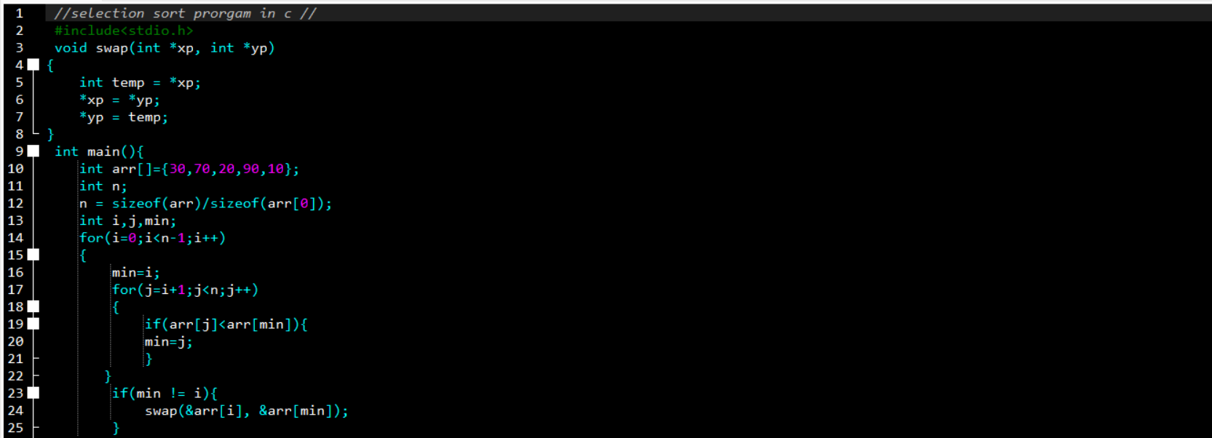

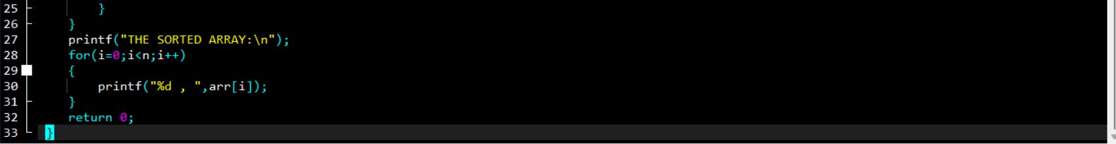

OUTPUT:

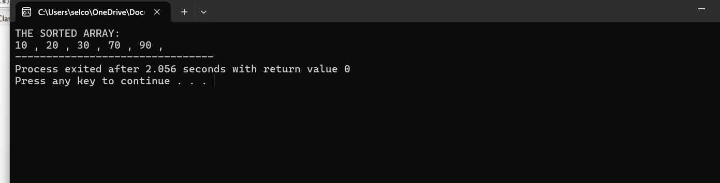

2)BUBBLE SORT

CODE:

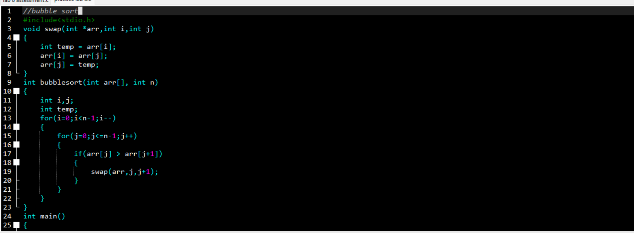

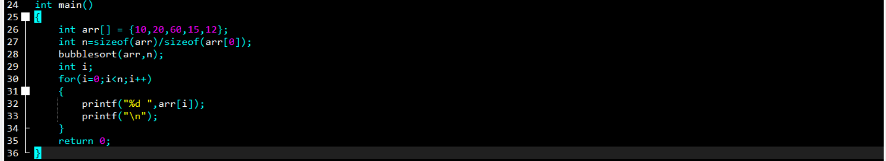

OUTPUT:

3)INSERTION SORT:

CODE:

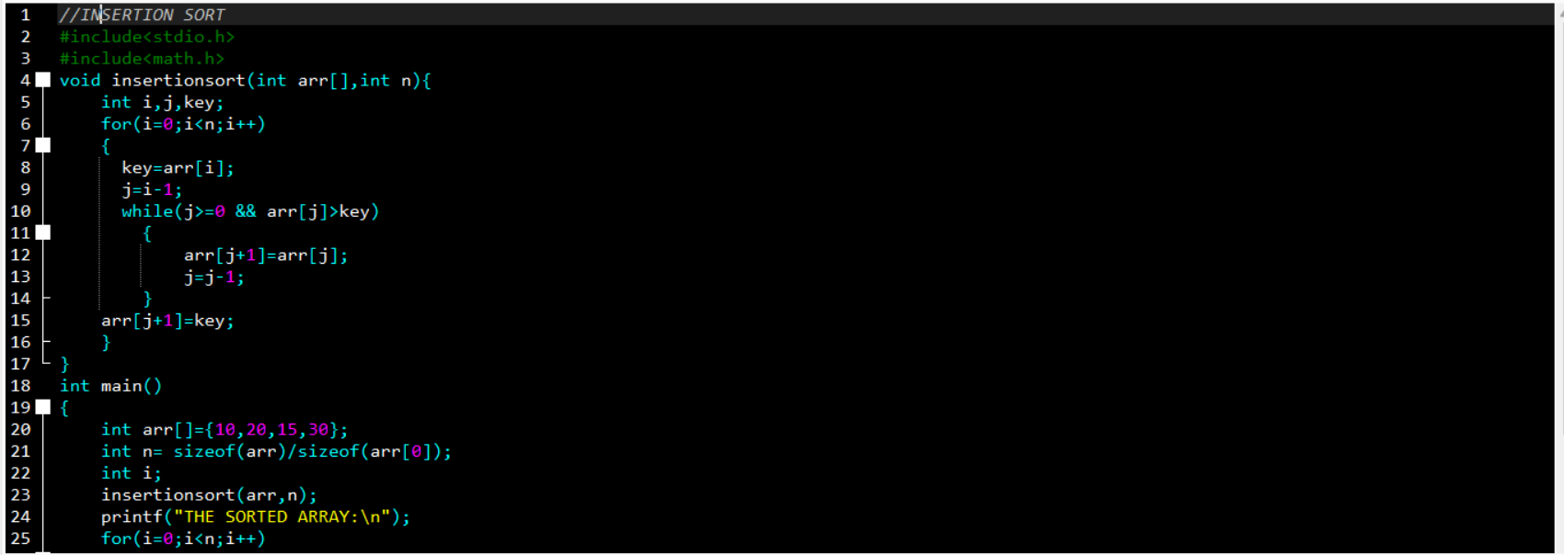

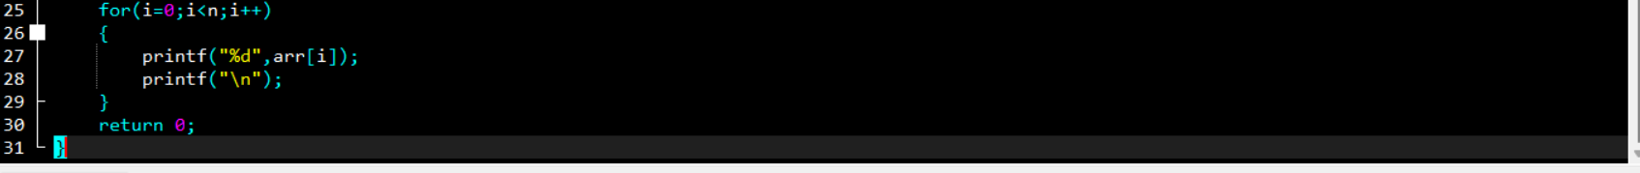

OUTPUT:

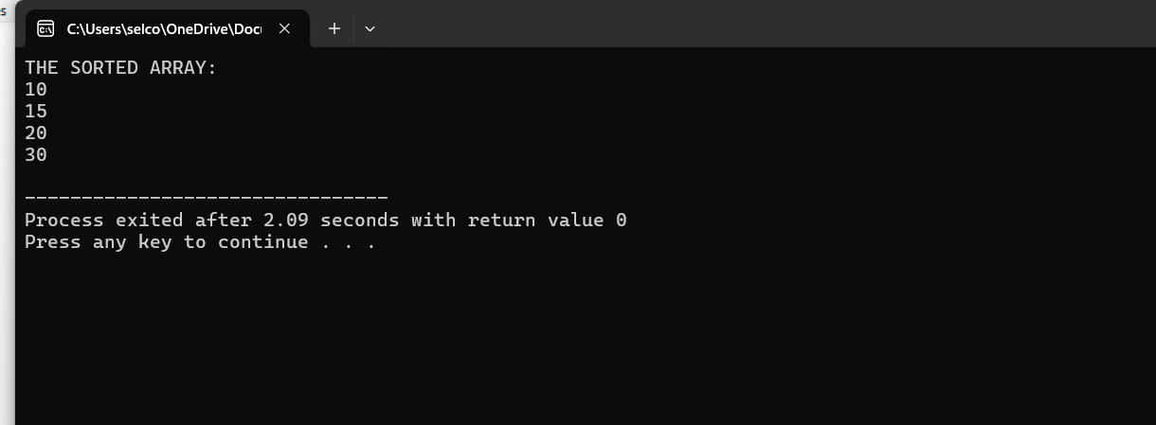

4)SEQUENTIAL SEARCH

CODE:

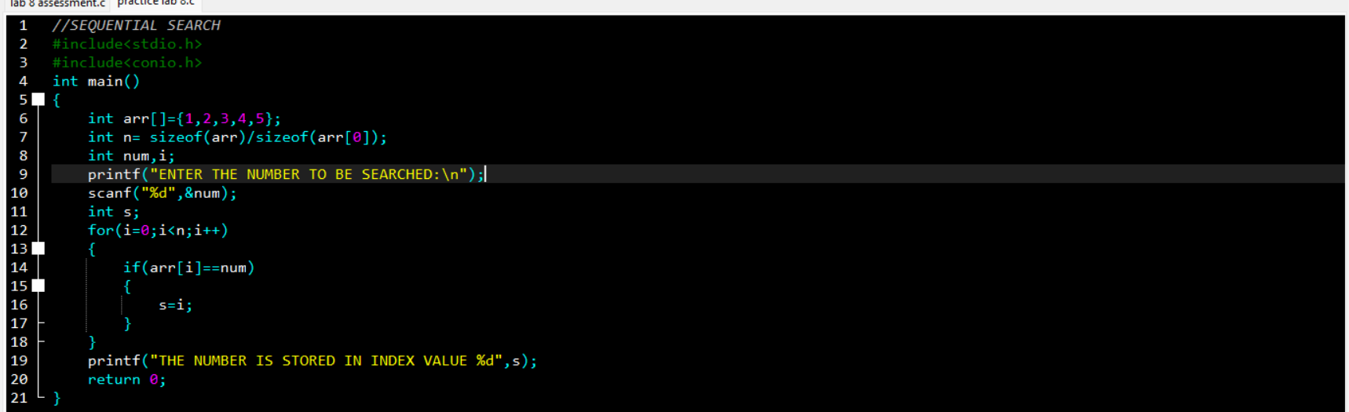OUTPUT:

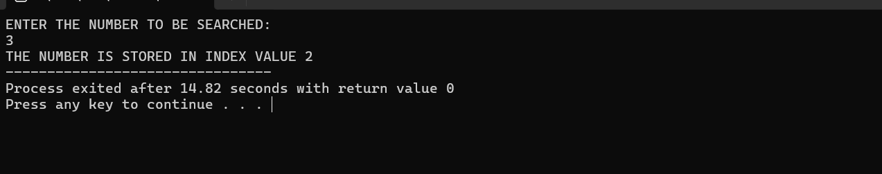

5)BRUTE FORCE STRING MATCHING

CODE:

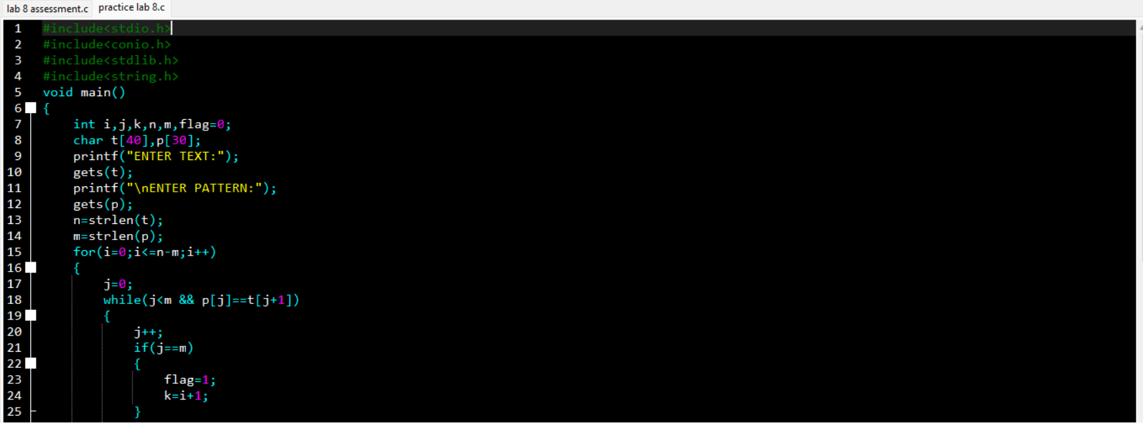

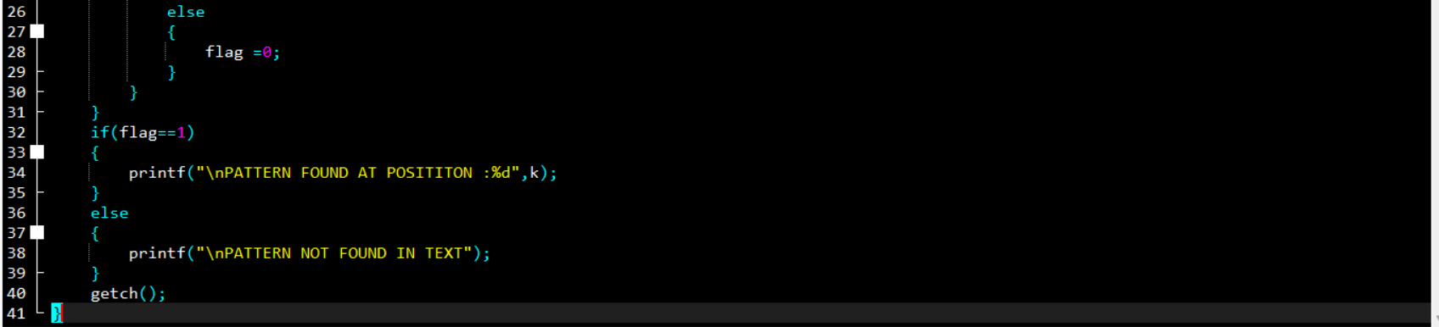

OUTPUT:

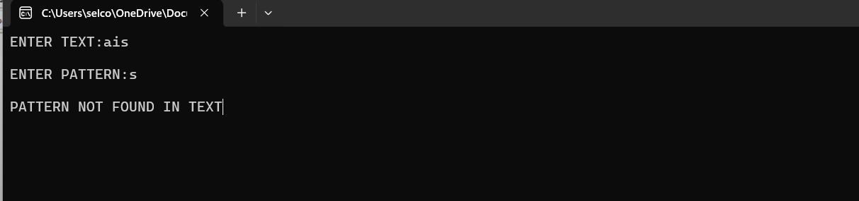

6)CONVEX HULL

CODE:

7)CLOSEST PAIR

CODE:

OUTPUT:

8)EXHAUSTIVE SEARCH

CODE:

OUTPUT: